FSCT 8561 – Lab 8: Steganographic Analysis
By: Jose Bangate, A01271709

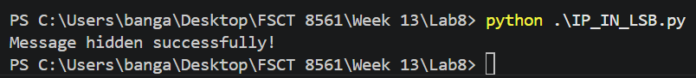
Part A – Manual LSB Manipulation

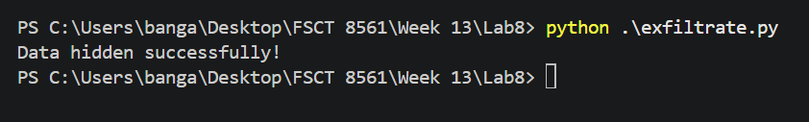
Part B – Stepic

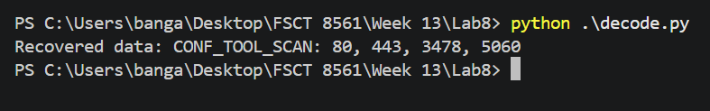
Part C – Verification & Analysis

